**Research report power supply**

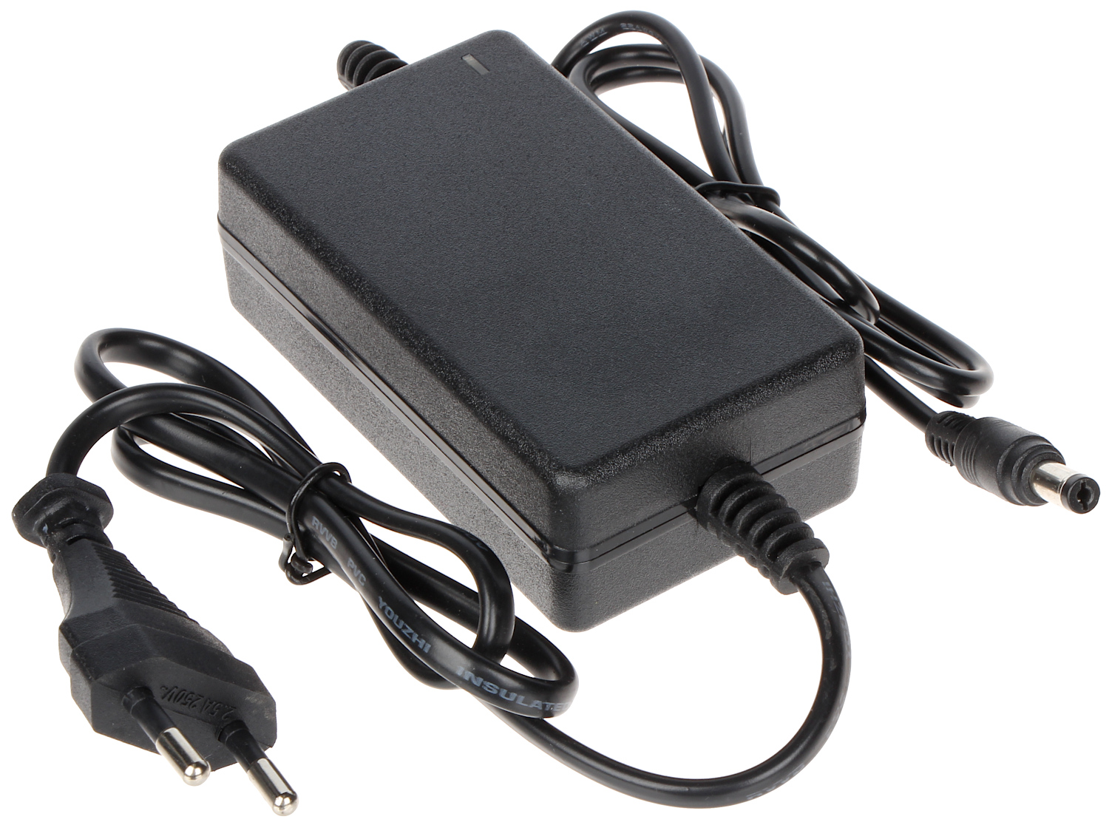

02-03-2020, written by Mart-Jan Koedam

The portable planetarium project is a project where the team is going to build a portable, small planetarium. Therefore the team is going to use microcontrollers, motors, and lasers.

While looking for the best power supply for the planetarium project, 3 things should be considered to find the best power supply:

1. Voltage
2. Modularity
3. Safety

***Voltage***

For the portable planetarium, several factors play a role in calculating the total voltage the power supply must deliver;

* The Arduino/Raspberry Pi
* The motors for the mirrors
* The lasers

The Arduino/Raspberry Pi does not need a very high voltage as a laptop does for example. 5V is enough to power it. The lasers will be powered directly from the Arduino/Raspberry Pi and do not require that high of a voltage because the light of the lasers is not very bright and the lasers fit into the budget. Now only one factor remains: The motors.

From what can be concluded from the first version of the research report on *Motor coordination, mirror calibration, and their combination*, the servo motors required for the rotation of the mirrors will use around 5-6V to operate, which means the Arduino/Raspberry Pi alone is not going to be enough to power them, so a bigger power supply is required for this project. A power supply that supplies up to 9-12V will be enough to power the Arduino/Raspberry Pi plus because a motor only needs 5-6V. When more than one motor is being used it is recommended to use an extra power supply.

A good way to power the motors and the Arduino/Raspberry Pi using the same power supply is to use the MB102, a breadboard power supply module.

This power supply module can handle up to 12V and output this at 3.3V or 5V.

Some more information on the module: (see figure 1)

There are two power supply ports on the left side, a DC port and a USB port.

On the right side, there are two ports of power output. The power voltage of both ports can be switched between 3.3V and 5V by the jumper cap. For this project, only the 5V port is required.

The USB port can only supply 5V. So if the USB port is used as power supply, the jumper cap of the output port must be at 5V; or else, there will be no power supply.

The DC input port uses a 5.5mm/2.1mm plug, with a voltage ranging from 6.5V~12V. With a DC input, the output ports could switch between 3.3V and 5V.

“*12V is the voltage limit. If you use an AD-DC adapter, it’s recommended to use 9V in case of an unsteady voltage which may burn the board.[1]*”

Because of the risk of burning the board, a DC power supply is required when using 12V.

***Modularity***

modularity is the degree to which a system's components may be separated and recombined, often with the benefit of flexibility and variety in use[2].

In this case, the power supply can have multiple plugs for different voltages so that different parts of the project can be tested individually.

Also, the cable-management will be a lot easier while there are no unused cables while still having the option to choose from multiple outputs.

***Safety***

Now that the most crucial parts for choosing a power supply have been taken care of, it’s safety also needs to be considered. When using the 12V power supply, secure housing is required so that the wires cannot be touched.

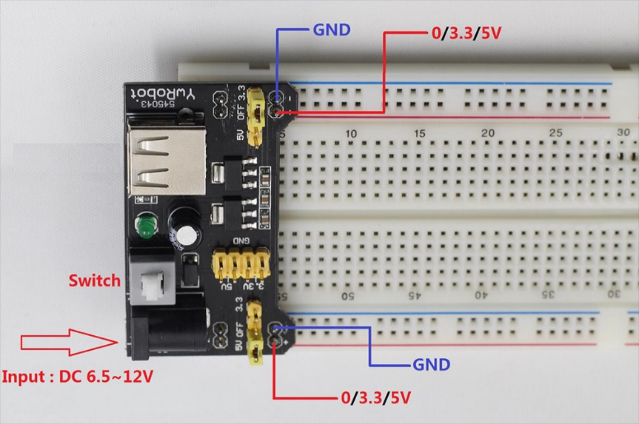

*Figure 1: The MB102 breadboard power supply module.*

**Bibliography**

Britt Reijnders (March 9, 2020), *Research Report Laser Projection.*

Sunfounder (March 20, 2017), *How to use YwRobot power Supply Properly.* From

<http://wiki.sunfounder.cc/index.php?title=How_to_use_YwRobot_Power_Supply_Properly>

Wikipedia (February 9, 2020), *Modularity.* From <https://en.wikipedia.org/wiki/Modularity>

PeterVis (Unknown), *YwRobot Power Supply.* From

<https://www.petervis.com/Raspberry_PI/Breadboard_Power_Supply/YwRobot_Breadboard_Power_Supply.html>

AvaDirect (April 8, 2016), *How to choose a power supply.* From <https://www.avadirect.com/blog/choose-power-supply/>

1. Sunfounder (March 20, 2017), *How to use YwRobot power Supply Properly.*
2. Wikipedia (February 9, 2020), *Modularity.*